**INTRODUCTION:**

* LiDAR = Light Detection and ranging.
* Light waves are used in this case to determine the range.
* It has a LiDAR and a detector (Photodiode ckt is used).
* LiDAR can precise anything more than RADAR.
* Used in object detection and 3D mapping, it also works in every harsh environment.
* By rotating the light, the distance between two objects can also be measured.
* LiDAR components are: Laser, Detector, Optics and Rotating Mechanism, Timing Electronics, Computer, GPS and IMU (Inertial Measurement Unit).

**Working principle:**

The light is fall on the object and the reflected wave is detected by the detector. The time is measured between the arrival and transmitted pulse. If the distance between the detector and the object is D then D = (speed of light*Time)/2. Multiple returns can be measured for each pulse. Up to 2,00,000+ pulses/second can be measured. Here, vertical accuracy is better than planimetric.

**Point Cloud:**

Point clouds are sets of points that describe an object or surface. To create a point cloud, laser scanning technology like LiDAR can be used. Each point contains an ample amount of data that can be integrated with other data sources or used to create 3D models.  
Further details: <https://community.safe.com/s/article/point-cloud-tutorial>

**Spatial Resolution:**

In terms of digital images, spatial resolution refers to the number of pixels utilized in construction of the image. Images having higher spatial resolution are composed with a greater number of pixels than those of lower spatial resolution.  
Further details: <https://www.microscopyu.com/tutorials/spatial-resolution-in-digital-imaging#:~:text=In%20terms%20of%20digital%20images,those%20of%20lower%20spatial%20resolution>.

**Scanning mechanisms:**

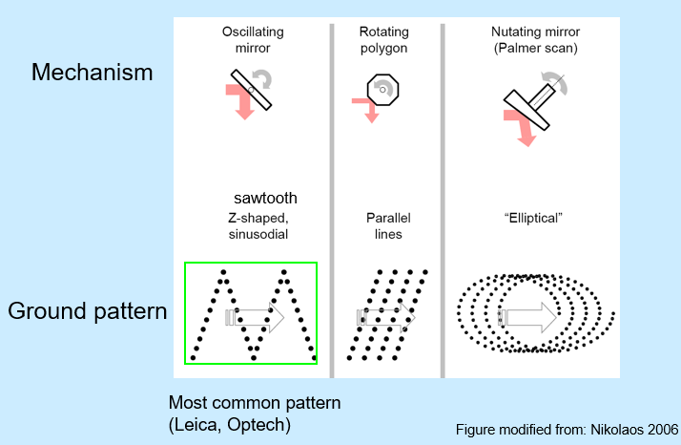

**LiDAR data:**

Usually, the raw data of LiDAR are XYZ points.  
In case of high spatial resolution in forestry areas, the laser footprint data on ground should be less than or equal to 0.50 meters, typical density is 0.5 to 20+ pulses/m2. In case of large volumes of data, 5000-60000+ pulses/hectare are applied and among them 10 to 100+ thousands of pulses returns/hectare. As the post spacing increases in a LiDAR system, the footprint size decreases. The number of returned pulses from the target varies the LiDAR sensor systems. The surfaces also play a vital role in LiDAR data acquisition. Highly reflective surfaces saturate some of its incident lasers. The reflectivity determines whether the object will be detectable to the LiDAR or not. The reflectivity of some elements is shown below:

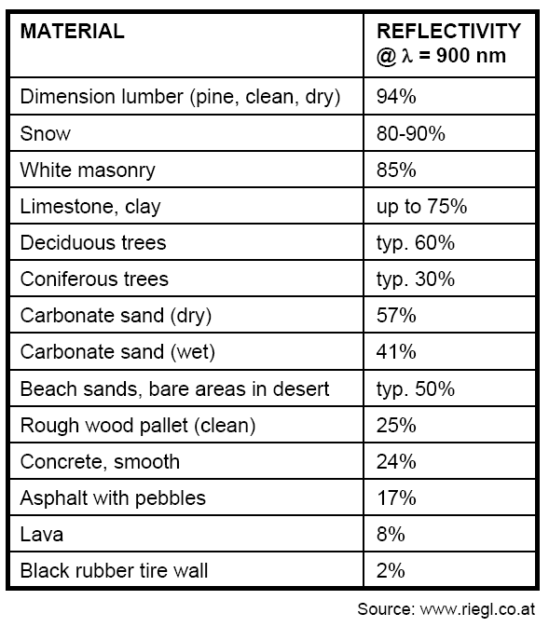

LiDAR data ordering method is shown below:

|  |  |
| --- | --- |
| Data acquisition | There are a number of private companies, academic institutions, and government agencies that produce and provide LiDAR data. |
| Timing | There are a number of time constraints associated with LiDAR collection and delivery: • Flight schedules can be delayed due to weather and environmental factors • Project areas may be large enough that multiple flights are needed • Post processing of millions of raw data points can be time consuming • Producing additional deliverables can delay the delivery schedule   * Leaf-on or leaf-off. |
| Costs | Cost can vary depending on size of project, horizontal postings (point density), and project location. Cost may also increase based on additional product requests (i.e., DEMs, DTMs, contours, etc.), specific accuracy requirements, or licensing restrictions.  Most current estimated:   * + LiDAR: $1-$4/hectare (1 hectare = ~2.5 acres) (640 acres = 1mi2)   + Aerial photography: pennies/ hectare (slight difference in cost for non stereo vs. stereo) |
| Formats | Common LiDAR Data Exchange Format - .LAS Industry Initiative (ASPRS). The LAS file format is a public file format for the interchange of LiDAR data between vendors and customers. This binary file format is an alternative to proprietary systems or a generic ASCII file interchange system used by many companies.   * + Know & understand the flight acquisition parameters   + Always get the raw data (it can be reprocessed later with newer techniques/algorithms)   + Get an intensity image |

**LiDAR Data Error Sources:**

1. Acquisition Scan angle: LiDAR data should be acquired within 18 degree of nadir(The nadir, is the direction pointing directly below a particular location; that is, it is one of two vertical directions at a specified location, orthogonal to a horizontal flat surface there. Since the concept of being below is itself somewhat vague, scientists define the nadir in more rigorous terms.) as above thie angle the LiDAR footprint got distorted.